**Final Project**

**Fiscal Policy Measures on Economic Growth of Pakistan**

**FINAL PROJECT**

**SUBMITTED TO THE DEPARTMENT OF ECONOMICS,**

**VIRTUAL UNIVERSITY OF PAKISTAN**

**Submitted By**

**Saba Umar**

**MC210200672**

**Virtual University of Pakistan**



**Submitted on 30th June, 2023**

**Department of Economics,**

**Virtual University of Pakistan**

**Acknowledgement**

Above all, I would like to thank our Supervisor **Kanwal Zahid,** who has been a constant source of inspiration. I would also like to thank our **Virtual University** for providing me with this wonderful opportunity to work on a project with the topic **“Fiscal Policy Measures on Economic Growth of Pakistan”**. She encouraged us to think creatively and motivated us to work on the task without thinking about it. She was there to help me every step of the way, and her motivation is what helped me complete this project successfully. She was fully supportive and provided us with various learning aids that were required to complete this project.

She believed in us even when we couldn't believe we could do it. We are also grateful to each member of this group. It was the contribution of each individual who contributed to the success of this task. We were always there to lift each other up and that helped us stay together until the end. We thank our parents for always trusting us and teaching us to believe in our abilities and strength and never give up until the goal is achieved. The completion of the project would not have been possible without their help and insights. We are grateful to all our friends who have given us moral support, and above all we are grateful to God for being with us and giving us the wisdom and ability to accomplish this task.

**Saba Umar**

**Msc Economic**

**Executive Summary**

**1.1-** For developing countries like Pakistan, the impact of fiscal policy initiatives on economic growth is a major concern. Pakistan faces a number of economic problems such as huge trade deficits, low levels of foreign direct investment and high inflation rates. These difficulties severely hampered the nation's economic expansion and development. The significance of this study lies in its potential to shed light on how well Pakistan's fiscal policy initiatives are working in stimulating economic growth. The study's findings will be critical in guiding the development of effective solutions by policymakers to address the nation's economic problems. The research will also expand the body of knowledge on macroeconomic policies and offer a thorough analysis between fiscal policy measures and economic growth in the context of developing countries. In conclusion, this study is crucial because it will shed light on how Pakistan's fiscal policy initiatives affect the country's economic expansion. The findings of the study will have substantial implications for decision-makers in government, academia and business as they will assist in the formulation of effective plans to support the country's economic development.

**1.2-** The purpose of this study to analyze the impact of inflation rate on economic growth of Pakistan, impact of government spending and tax revenue on economic growth, impact of interest rate/ exchange rate. These goals can be achieved within the given constraints and time horizon because they are supported by logical data. They are written in operational terms that clearly explain what will be done, where and for what purpose, and explicitly state and include the issues under consideration. In this research simple regression analysis will be used in this methodology.

**1.3-** The findings of this study will also contribute to our understanding of Pakistan's economic growth drivers and their interaction with fiscal policy initiatives. This study will help in designing targeted policies that are better suited to the Pakistani context by identifying important drivers of economic growth and their relationships with fiscal policy measures.

**1.4-** Application of the findings of the study is expected to lead to cutting-edge fiscal policy initiatives that will better support Pakistan's economic growth.The significance of this study lies in its ability to expand knowledge on the relationship between fiscal policy initiatives and Pakistan's economic expansion. The findings of this study should inform policy makers about the effectiveness of various fiscal policy initiatives in promoting economic growth in Pakistan. Fiscal policy acts on the economy through factors of output or productivity. Increase in the GDP growth rate characterizes the economic development in the country. In the current study fiscal variables included in the model consist of a set of net tax revenues, the real interest rate, public expenditure, consumer price index, capital stock and population growth rate as independent variables and then measure their impact on the overall growth marked GDP growth rate.

**1.5-** The recommendations presented in the study are expected to assist decision makers in creating policies that better match the demands and priorities of Pakistan's economy. In addition to policymakers and academics, this study has implications for stakeholders in the public and private sectors. The study's conclusions and recommendations will help improve awareness of the role of fiscal policy measures in promoting economic growth and enable Pakistan's public conversation on economic policy issues to become more informed. Overall, this research has the potential to significantly advance knowledge on the relationship between fiscal policy initiatives and economic growth in Pakistan and support the creation of more effective growth-promoting policies for the nation. This recommendation relationship between fiscal deficit and economic growth in Pakistan to see if there is a threshold the level of fiscal deficit that could serve as a policy benchmark in enforcement growth through fiscal expansion. However, the benefits such a policy will only be implemented if public spending is targeted in the long term investments that bring an adequate return in infrastructure, education, healthcare and other development projects. Such public investments can also improve the marginal productivity of private capital. This means that if public capital was supposed to complement private capital, then investment in public capital would "crowd out" private investment, thereby strengthening it the process of economic growth.

Table of Contents

Section I 8

Chapter 1: 8

1.1 Introduction of Study 8

1.2 Background of the Study 9

1.3 Objectives of the Study 10

1.4 Significance of Study 10

Chapter 2: Project Proceedings 11

2.1 Review of Literature 11

Chapter 3: Research Methodology 12

3.1 Model Specification 12

3.2 Data 12

3.3 Variables 12

3.4 Methodology 13

3.5 Data Processing Tool 13

Chapter 4: Estimation Results and Analysis 14

4.1 Data 14

4.2 Regression Analysis 14

4.3 CPI 15

4.4 IRS 15

4.5 GFCF 15

Chapter 5: Conclusion, Recommendations & Limitations 16

5.1 Conclusion 16

5.2 Recommendations 16

5.3 Limitations 17

Section II 19

**Specimen List of Illustrate**

Figure 1.1: Data used in Regression Analysis 14

Figure 1.2: Regression Analysis Summary Output 14

Figure 1.3: Summary of GDP and CPI 15

Figure 1.4: Summary of GDP and IRS 15

Figure 1.5: Summary of GDP and GFCF 15

# 

# Section I

## Chapter 1:

### Introduction of Study

An important factor that affects the overall development and prosperity of a nation is its rate of economic growth. Pakistan uses numerous fiscal policies to accelerate its economic growth as a developing country. The main purpose of the research proposal is to examine the impact of Pakistan's fiscal policy initiatives on economic growth. The proposal will describe the significance of the study, offer a thorough schedule for its implementation, and offer recommendations for data sources and techniques to be used in the analysis. This study will expand knowledge about macroeconomic policy by analyzing the link between this fiscal policy and economic growth. It will also shed light on the economic development of Pakistan.

The proposed project attempts to examine how Pakistan's fiscal policy decisions affect the country's economic expansion. The government's employment of spending and tax policies that affect the economy is called fiscal policy. In order to stimulate economic growth in Pakistan, the project will examine the effectiveness of various fiscal policy initiatives such as government investment in infrastructure development, tax rate adjustments and other monetary policies. In addition, the study will look at how various fiscal policy measures and economic indicators such as GDP, unemployment rate, inflation and foreign direct investment (FDI) interact with each other. The aim of this study is to provide a thorough understanding of this effectiveness of fiscal policy measures in promoting economic growth in Pakistan by examining the available data. The findings of the study will have substantial implications for decision makers in government, academia and business as they will assist in making effective plans to support Pakistan's economic development. There are various reasons why this study is necessary.

First, Pakistan has had several years of below-average economic growth. The nation has been unable to meet its economic growth targets despite adopting a series of fiscal reforms. It is crucial to find out whether fiscal policy initiatives are effective in promoting economic growth in Pakistan.

Second, little is known about the effectiveness of fiscal policy measures in developing countries such as Pakistan, as the literature currently available on fiscal policy and economic growth primarily focuses on industrialized countries. By offering insight into the effects of fiscal policy measures on economic growth in the context of developing countries, this research contributes to filling a knowledge gap in the literature.

Third, Pakistan's economy faces a number of challenges, including a widening trade deficit, high inflation, and a lack of foreign direct investment. Therefore, it is crucial to pinpoint the variables that can support national economic development. This study will provide policy makers with a thorough understanding of how fiscal policy measures affect economic growth, which will help them, formulate effective plans to address Pakistan's economic challenges.

Finally, the importance of this research cannot be overstated as it will advance our understanding of macroeconomic policies and shed light on Pakistan's economic growth. The findings of the study will be useful to academicians, researchers and business professionals and can help in making policy decisions that will promote economic growth and development of Pakistan.

### Background of the Study

For developing countries like Pakistan, the impact of fiscal policy initiatives on economic growth is a major concern. Pakistan faces a number of economic problems such as huge trade deficits, low levels of foreign direct investment and high inflation rates. These difficulties severely hampered the nation's economic expansion and development.

Pakistan has tried a number of fiscal policy initiatives over the years to support economic expansion. These measures include adjustments to tax rates, increased public investment in infrastructure and other monetary policies. Despite these efforts, the nation has failed to meet its economic growth targets. It is essential to find out whether these fiscal policy initiatives are successful in promoting economic growth in Pakistan.

The impact of fiscal policy changes on economic growth in developing countries has been the subject of numerous studies. Indeed, these studies produced conflicting findings; while some argue that changes in fiscal policy have a significant impact on economic growth, others argue that they have little impact. However, most of these studies have focused on the effects of fiscal policy measures on developed countries; for example, little is known about their effectiveness in Pakistan.

The significance of this study lies in its potential to shed light on how well Pakistan's fiscal policy initiatives are working in stimulating economic growth. The study's findings will be critical in guiding the development of effective solutions by policymakers to address the nation's economic problems. The research will also expand the body of knowledge on macroeconomic policies and offer a thorough analysis between fiscal policy measures and economic growth in the context of developing countries.

In conclusion, this study is crucial because it will shed light on how Pakistan's fiscal policy initiatives affect the country's economic expansion. The findings of the study will have substantial implications for decision-makers in government, academia and business as they will assist in the formulation of effective plans to support the country's economic development.

### Objectives of the Study

The purpose of this study is to:

* Analyze the impact of inflation rate on economic growth of Pakistan
* See the impact of government spending and tax revenue on economic growth of Pakistan
* Observe the impact of interest rate / exchange rate on economic growth of Pakistan

These objectives can be achieved within the given constraints and time horizon because they are supported by logical data. They are written in operational terms that clearly explain what will be done, where and for what purpose, and explicitly state and include the issues under consideration.

### Significance of Study

The significance of this study lies in its ability to expand knowledge on the relationship between fiscal policy initiatives and Pakistan's economic expansion. The findings of this study should inform policy makers about the effectiveness of various fiscal policy initiatives in promoting economic growth in Pakistan.

The findings of this study will also contribute to our understanding of Pakistan's economic growth drivers and their interaction with fiscal policy initiatives. This study will help in designing targeted policies that are better suited to the Pakistani context by identifying important drivers of economic growth and their relationships with fiscal policy measures.

Application of the findings of the study is expected to lead to cutting-edge fiscal policy initiatives that will better support Pakistan's economic growth. The recommendations presented in the study are expected to assist decision makers in creating policies that better match the demands and priorities of Pakistan's economy.

In addition to policymakers and academics, this study has implications for stakeholders in the public and private sectors. The study's conclusions and recommendations will help improve awareness of the role of fiscal policy measures in promoting economic growth and enable Pakistan's public conversation on economic policy issues to become more informed.

Overall, this research has the potential to significantly advance knowledge on the relationship between fiscal policy initiatives and economic growth in Pakistan and support the creation of more effective growth-promoting policies for the nation.

## Chapter 2: Project Proceedings

### Review of Literature

Using quarterly data from 1981 to 2016, Nasir Iqbal, Musleh ud Din and Ejaz Ghani (2017) examined the effect of Pakistan's fiscal deficit on economic growth. According to the study, the fiscal deficit has a negative and significant effect on economic growth in both the short and long term.

Using annual data from 1973 to 2010, Syed Tehseen Jawaid, Imtiaz Arif and S.M. Naeemullah (2010) conducted a comparative analysis of Pakistan's monetary and fiscal policies. According to the study, monetary policy has less influence on the economy than fiscal policy. It was also found that the government's fiscal policy significantly affects output growth.

Using annual data from 1980 to 2017, Farhan Ahmed, Suman Talreja, Yasir Aman, and Govinda Lohana (2018) examined the link between Pakistan's fiscal policy and economic stability. According to the study, fiscal policy significantly affects macroeconomic stability in the long term. In particular, government debt and fiscal deficits have been found to have a detrimental effect on economic stability.

Muhammad Suleman and Muhammad Naimatullah Babar (2022) tracked the impact of fiscal policy on economic development in Pakistan using annual data from 1972 to 2019. According to the study, fiscal policy has a favorable and significant short-term effect on economic growth. However, the long-term effects are detrimental; suggesting that over-reliance on fiscal policy may not be sustainable.

Using annual data from 1972 to 2011, Imran Hanif, Imran Sharif Chaudhry, and Sally Wallace (2014) examined the association between fiscal independence and economic growth in Pakistan. According to the study, short-term economic growth benefits from budgetary autonomy.

However, the long-term effects are proving to be detrimental, suggesting that in order to sustain economic growth; the government must strike a balance between fiscal independence and fiscal restraint.

## Chapter 3: Research Methodology

### Model Specification

GDP = β0 + β1GS + β2 TR + β3IR + β4 IR + ε

Simplify:

GDP = Gross Domestic Product i.e. Economic Growth

GS = Government Spending

TR = Tax Revenue

IR = Interest Rate

IR = Inflation Rate

ε = Error

### Data

* Time series data has been used in this research and
* Data will be gathered from World Development Indicators (WDI)

### Variables

1. **Dependent variable: GDP i.e. Economic Growth**

This variable measures the growth rate of the economy in Pakistan over time. It is the main variable of interest and will be used as the dependent variable in the regression model.

1. **Independent variable: Fiscal Policy Measures**

These variables will be used to measure the impact of different fiscal policy measures on economic growth. They include government expenditure, tax revenue and fiscal deficit.

1. **Government spending**

Government expenditure refers to government spending on goods and services and is a major component of GDP. Government spending policies such as setting budget targets, adjusting taxes, increasing public spending and public works are very effective tools in influencing economic growth.

1. **Tax Revenue**

Tax revenue is revenue collected by governments through taxes. Taxes are the primary source of government revenue.

1. **Interest Rate**

In Pakistan, interest rates are decided by the State Bank of Pakistan.

1. **Inflation Rate**

This variable is a measure of the change in the price level over time. The rate of decline in the purchasing power of money is approximately the same.

### Methodology

Simple Regression Analysis will be used in this method

### Data Processing Tool

Simple Regression Analysis can be performed using MS Excel as data processing tools.

## Chapter 4: Estimation Results and Analysis

### Data

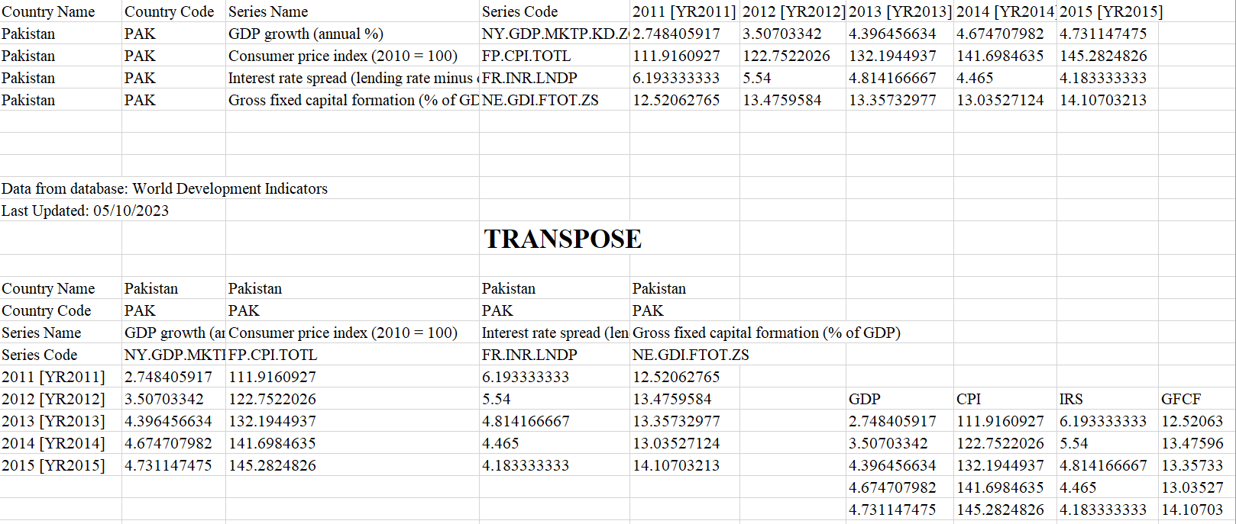

Fig 1.1: Data used in Regression Analysis

### Regression Analysis

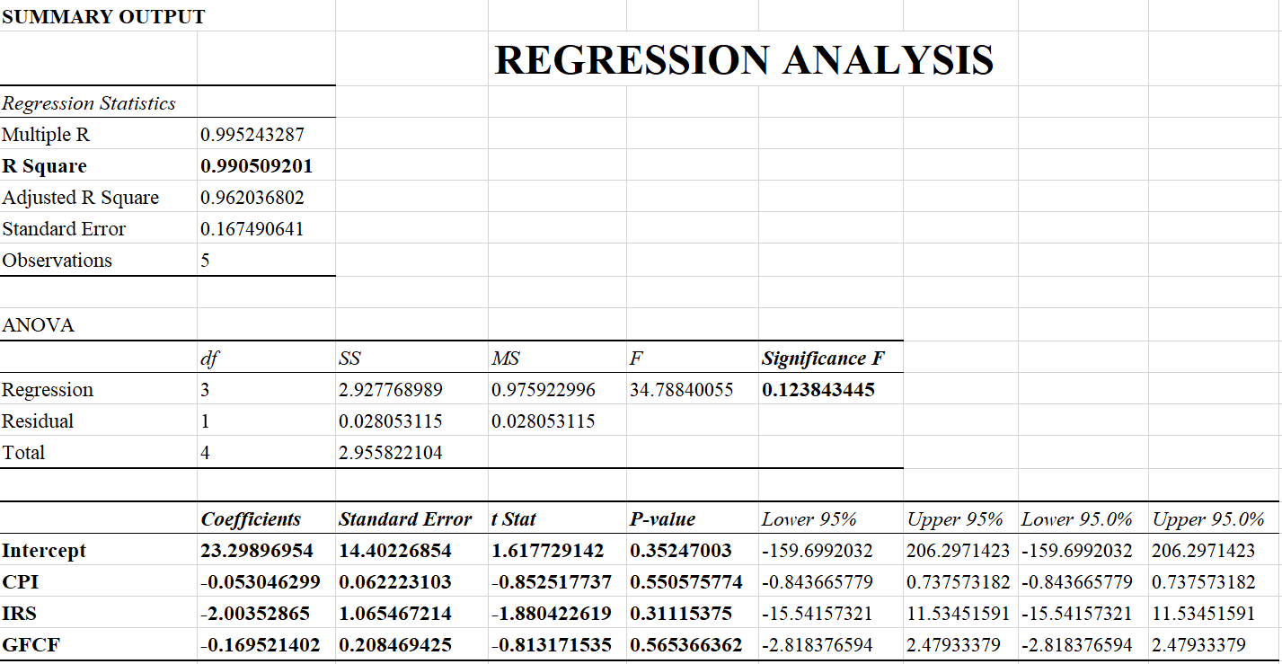

Fig 1.2: Regression Analysis Summary Output

### CPI

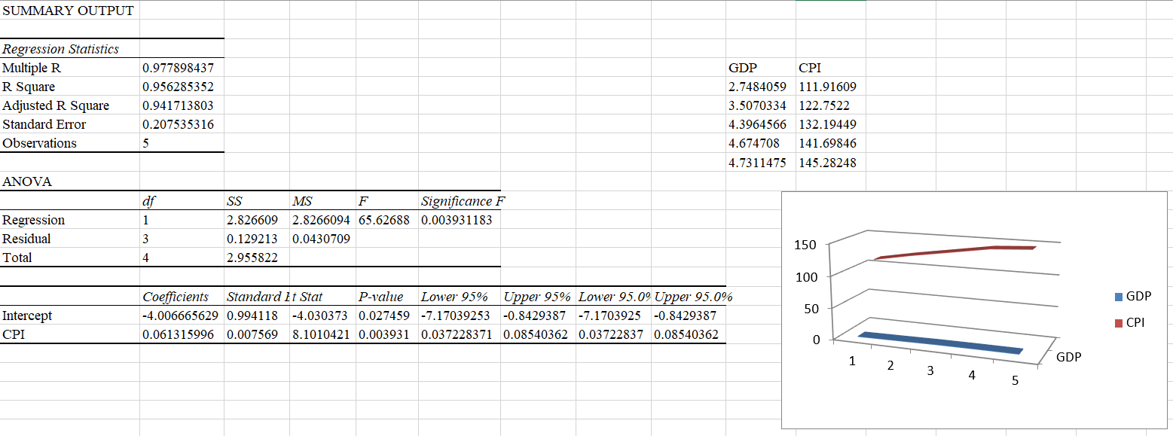

Fig 1.3: Summary of GDP and CPI

### IRS

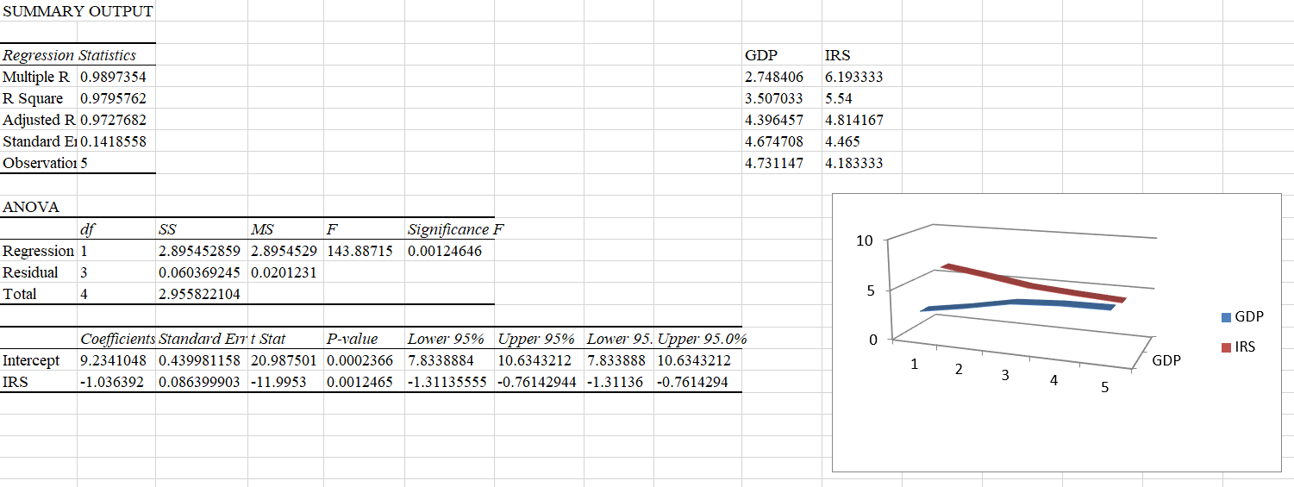

Fig 1.4: Summary of GDP and IRS

### GFCF

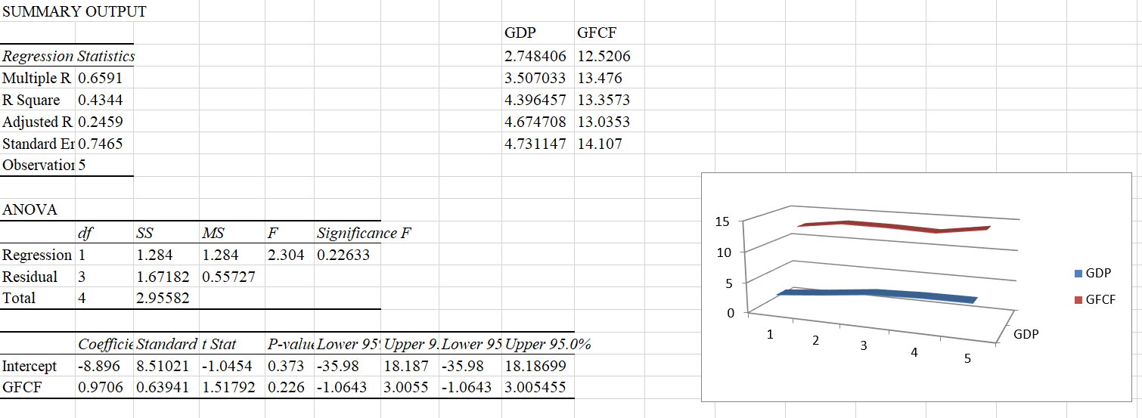

Fig 1.5: Summary of GDP and GFCF

## Chapter 5: Conclusion, Recommendations & Limitations

### Conclusion

This study analyzes the effect of fiscal policy on economic growth in Pakistan. This study examined the impact of fiscal policy on economic growth using data series from 2011 to 2015. The key variables used in this analysis are gross domestic product (GDP), inflation rate (IR), interest rate spread (IRS), interest rate (IR), government spending (GS) and tax revenue (TR). The growth economic and the eigenvalue reveal that there are two co-integrating equations in the long run. To estimate the vector error correction model, lag length, VAR model estimation is required to determine the optimal lag length and VAR lag order selection criteria. This result revealed that there are three optimal lags according to the Akaik Information Criteria (AIC) and the Schwarz Information Criteria. Vector error correction reveals that in the long run there is a positive and significant relationship between gross domestic product (GDP), inflation rate (IR), tax revenue (TR), interest rate (IR), government spending (GS) and a positive relationship with economic growth (EG). Government spending is a Granger cause of GDP, but GDP is not caused by defense spending. Defense spending is a Granger cause of IR, but IR does not cause government spending. Tax revenue is a Granger cause of exchange rate, but exchange rate does not cause spending government. Inflation rate is the main cause of interest rate, INF but does not depend on distorting taxation. All other variables are not caused by each other. Sound fiscal policy can be instrumental in achieving sustainable economic growth by facilitating research and development programs, maintaining law and order conditions, promoting investment incentives, and alleviating poverty. While inefficient fiscal policy leads to high inflation, high interest rates and crowding out private investment. The living standard of the population can be improved only by such macroeconomic policies that can promote rapid and sustainable economic growth, alleviate poverty and bring stability in other macroeconomic indicators. In this regard, fiscal policy can be considered a crucial determinant of sustainable economic growth.

### Recommendations

Based on the findings of this study, several recommendations can be made to enhance the effectiveness of fiscal policy in promoting economic growth in Pakistan. Firstly, it is crucial for the government to prioritize and increase investment in infrastructure development. The positive relationship between government spending and economic growth indicates that allocating resources towards key infrastructure projects, such as transportation, energy, and telecommunications, can stimulate economic activity, create job opportunities, and attract foreign direct investment. By improving the country's infrastructure, Pakistan can enhance its competitiveness and facilitate sustainable economic growth.

Secondly, targeted tax reforms should be implemented to optimize tax collection and promote economic growth. The study emphasizes the significance of tax revenue in driving economic expansion. To achieve this, the government should consider simplifying tax procedures, broadening the tax base, and ensuring a fair distribution of the tax burden. Implementing such reforms can increase revenue generation for the government and provide a conducive environment for businesses to thrive, leading to higher economic growth.

Another crucial recommendation is to prioritize research and development (R&D) initiatives. The study highlights the role of fiscal policies in facilitating R&D programs. Therefore, it is recommended that the government invests in promoting research and development in key sectors such as technology, innovation, and agriculture. This investment can lead to technological advancements, increased productivity, and improved competitiveness in both domestic and international markets, ultimately driving economic growth.

Furthermore, to ensure the effectiveness of fiscal policy initiatives, it is essential to strengthen policy coordination and monitoring mechanisms. The government should establish clear communication channels and collaboration between relevant departments and agencies involved in fiscal policy formulation and implementation. Regular monitoring and evaluation of the impact of fiscal policies on economic growth can help identify any shortcomings and make necessary adjustments to maximize their effectiveness.

Lastly, enhancing transparency and accountability is crucial for effective fiscal policy. The government should strive to improve transparency in budgetary processes, public financial management, and resource allocation. This includes ensuring timely and accurate dissemination of fiscal information, engaging civil society organizations, and promoting citizen participation in budgetary decision-making. By fostering transparency and accountability, the government can build trust and confidence among stakeholders, leading to better policy outcomes and promoting sustainable economic growth.

### Limitations

While this study provides valuable insights into the relationship between fiscal policy and economic growth in Pakistan, there are several limitations that should be acknowledged. Firstly, the study relies on data series from the period of 2011 to 2015, and it is essential to recognize that economic conditions and policy dynamics may have changed since then. Future research should consider using more recent data to capture the evolving relationship between fiscal policy and economic growth accurately.

Secondly, it is important to acknowledge the potential presence of causality and endogeneity issues in the identified relationships. While the study establishes correlations, it does not establish causality definitively. To address this limitation, future research could employ advanced econometric techniques, such as instrumental variables or panel data analysis, to provide more robust causal inferences.

Furthermore, the study primarily focuses on domestic fiscal policy measures and their impact on economic growth, neglecting external factors and global influences. Considering the interconnectedness of economies, external factors such as global economic conditions, international trade dynamics, and geopolitical events can significantly influence economic growth. Future research could incorporate these external factors to provide a more comprehensive analysis.

Moreover, it is important to acknowledge that economic growth is influenced by a wide range of factors beyond fiscal policy, including monetary policy, institutional quality, political stability, and social factors. While this study focuses on fiscal policy measures, future research could explore the interactions between fiscal policy and these non-fiscal factors to gain a more holistic understanding of their combined impact on economic growth.

Finally, it is necessary to exercise caution when generalizing the findings of this study to other developing countries. The effectiveness of fiscal policy measures may vary across countries due to differences

# Section II

1. **Introduction of the Student**

**Last Degree Obtained:** B.A in English Literature

**Organization’s Name Where Currently Employed:**

Allied School Al-Rehman Campus Okara

**Designation:** Coordinator of Nursery

**Experience (years):** 8

1. **Bibliography**

**References**

1. Ahmed, Farhan & Talreja, Suman & Aman, Yasir & Lohana, Govinda. (2018). Fiscal Policy and Economic Stability: A Case of Pakistan. Jurnal Perspektif Pembiayaan dan Pembangunan Daerah. 6. 205-222.

10.22437/ppd.v6i2.5352.

1. Hanif, Imran & Scholar, Phd & Chaudhry, Imran & Wallace, Sally. (2014). Fiscal Autonomy and Economic Growth Nexus: Empirical Evidence from Pakistan. Pakistan Journal of Social Science. 34. 767-780.
2. Iqbal, Nasir & Din, Musleh & Ghani, Ejaz. (2017). The Fiscal Deficit and Economic Growth in Pakistan: New Evidence. THE LAHORE JOURNAL OF ECONOMICS. 22. 53-72. 10.35536/lje.2017.v22.isp.a3.
3. Jawaid, Tehseen. (2010). Comparative Analysis of Monetary and Fiscal Policy: A Case Study of Pakistan. NICE Research Journal. 3. 58-67.
4. Ministry of Finance. (2020). Economic Survey of Pakistan 2019-20. <http://www.finance.gov.pk/survey_1920.html>
5. Muhammad Suleman, Muhammad Naimatullah Babr. (2022). FISCAL EFFECTIVENESS AND ECONOMIC GROWTH IN PAKISTAN. Pakistan Journal of Social Research. ISSN 2710-3129 (P) 2710-3137 (O). Vol. 4, No. 3, September 2022, pp. 311-325.
6. Muhammad Usman, Miraj-Ul-Haq. (2017). Growth Effects of Fiscal and Monetary Policies in Pakistan. The Pakistan Development Review. 56:4 Part II (Winter 2017) pp.
7. Sarwar, Ghulam & Riaz, Noman. (2017). Impact of Fiscal Policy on Economic Growth in Pakistan. International Journal of Scientific and Engineering Research. 8. 142-148.
8. Suleman, Muhammad & Babar, Muhammad. (2022). FISCAL EFFECTIVENESS AND ECONOMIC GROWTH IN PAKISTAN. Pakistan Journal of Social Research.  
   04. 311-/pjsr.v4i03.718.
9. Syed Tehseen Jawaid & Faisal Sultan Qadri & Nasir Ali, 2011. "Monetary-Fiscal-Trade Policy and Economic Growth in Pakistan: Time Series Empirical Investigation," International Journal of Economics and Financial Issues, Econjournals, vol. 1(3), pages 133-138, September.